**Activity 2**

**Requirements:**

* **JFrame ✔**
* **JLabel ✔**
* **Font ✔**

**Groupmates:**

(List here the names of your group and their contribution)   
Jhon Brix G. Brion – Activity 2 Software Development.  
Shane Marie Mon – Activity 2 Documentation.

**Lab Activity Problem:**

1. Create a resume/cv using Java Swing, this includes:

* Personal Information ✔
* Educational Background ✔
* Skills (ICT/Computer Related) ✔
* Favorite Books / Favorite Movies ✔

Note: Send the java file and documentation

**Grade Matrix:**

Functionality : 50%

Documentation : 50%

100%

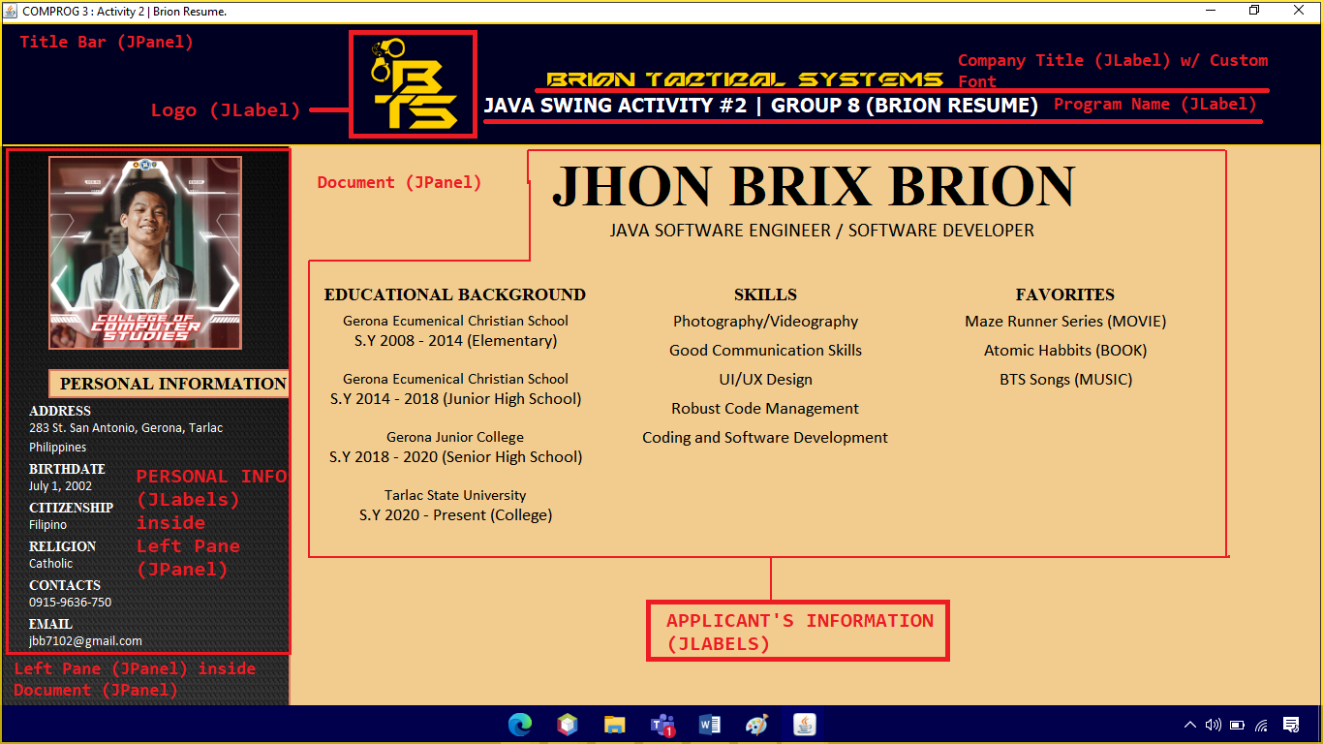This is the Java Swing Program which resembles a resume. There are two copies for this Program, one for Brion, Jhon Brix, and one for Mon, Shane Marie. This was made as an activity requirement submitted at February 18 2022 for the subject COMPROG 3.

Note : Source Code is too Large with a total of 1671 Lines of Code. The source code cannot be entered in the Document. so I inserted custom source codes such as Pictures inside a JLabel and Custom Fonts within the Project – Jhon Brix Brion

**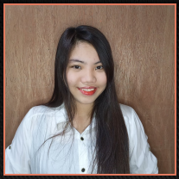****Company Logo** (JLabel)

**Brion’s Mugshot** (JLabel) **Mon’s Mugshot** (JLabel)

These are displayed using a JLabel where setIcon was used to display the Photos and adding imports such as javax.swing.ImageIcon; and java.awt.Image;  
Source Code :



  
**Company Name** (JLabel)

This is a Custom Font. Try-Catch was used to make acquire the custom font from the Project Directory. “Iron Shark” is the custom font used.   
  
Source Code :   
  
